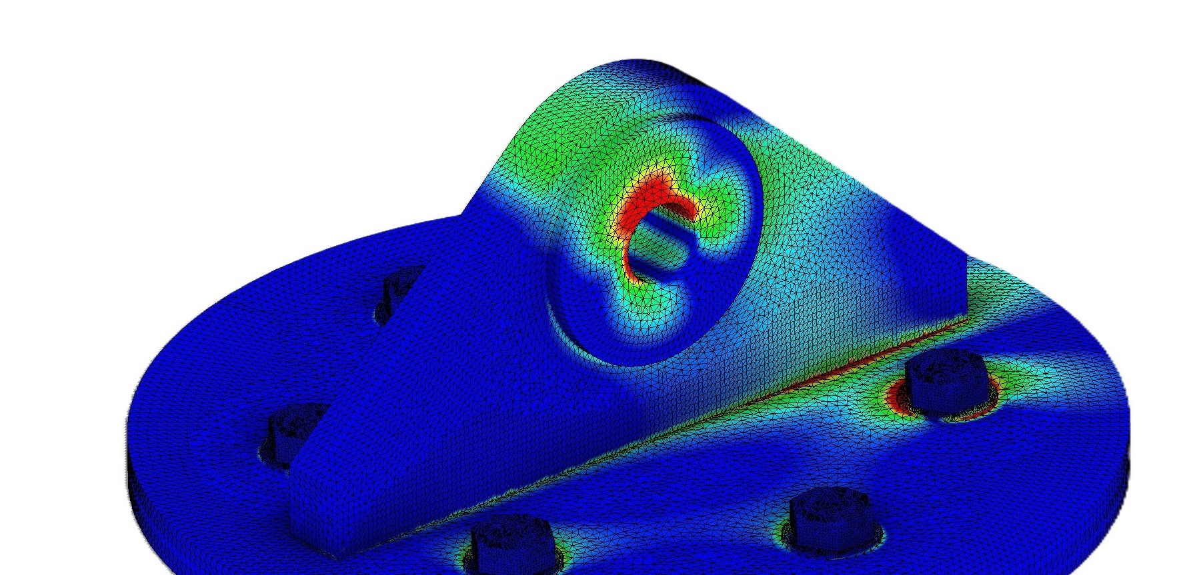

Padeye calculator is a tool used used in engineering and construction to determine the required dimensions and specifications for padeyes, which are integral for lifting and rigging systems.

Ook padeye calculator

Calculator help us to design a pad-eye to be used for lifting or lashing during transport. calculator considers a number of factors, to make sure the padeye can safely support the intended load without failing, including the weight of the load, the angle of lift, the material and thickness of the structure, and safety considerations.

It can be used for the design of a standard pad-eye with

1. No brackets

2. Single cheek plate on either side

It makes the following checks

1. Geometry check: Main plate radius, Shackle clearances

2. Stress Check for Pin Hole (Tensile, Bearing, Shear, Hertz stress)

3. Stress check for Base Plate (Tensile, Bending, Shear, Von Mises and Combined)

4. Stress Check for Base Weld (Tensile, Bending, Shear, Total Stress)

5. Shear Stress Check for Cheek Plate Weld

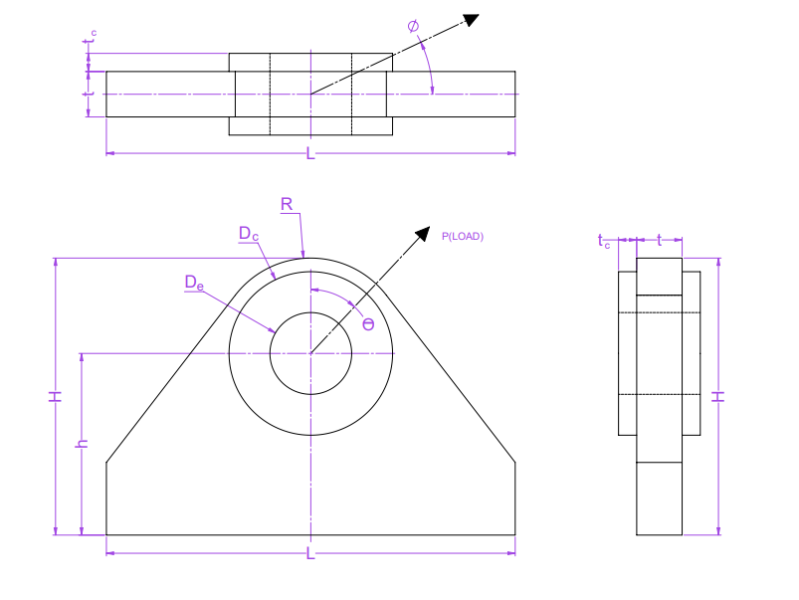

Padeye

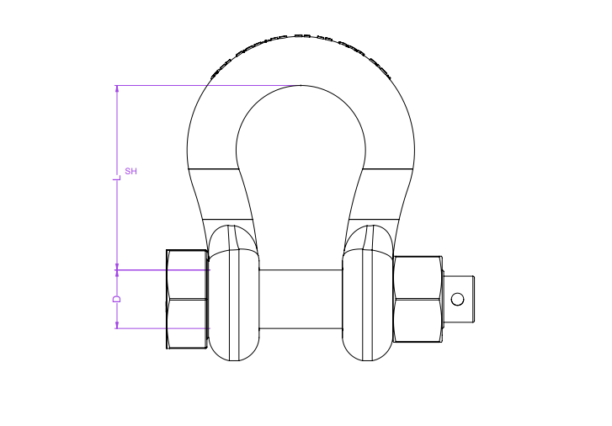

shackle

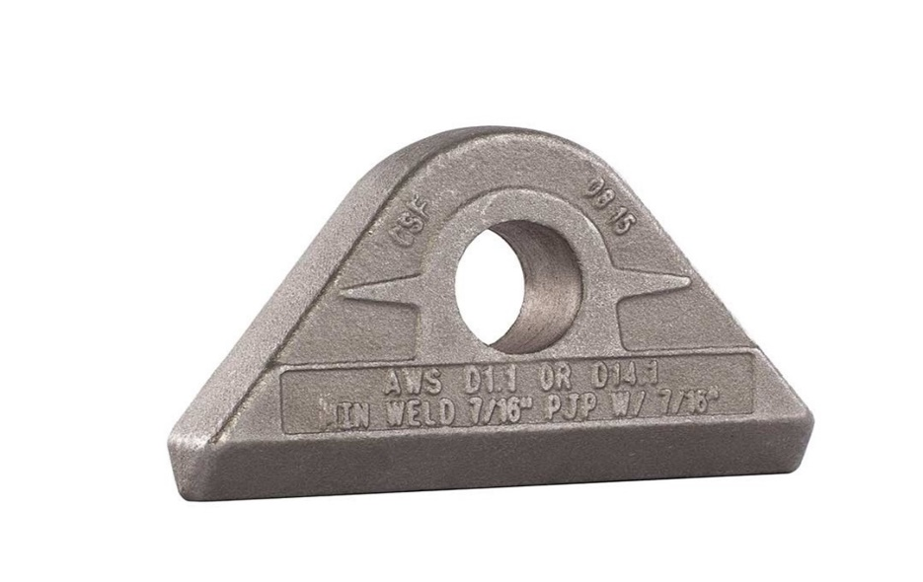Padeye: Plate having having hole and with or without occasional ring stiffeners (cheek plate)

welded to the main plate.

Drop down

Designed to withstand the forces associated during lifting. Lifting padeyes are typically used for lifting heavier or more complex loads.

Input parameters

* Yield strength: stress at which material start deform plastically (permanent changes in shape even after the load is removed).
* Tensile strength: maximum amount of tensile stress that a material can sustain before failure.
* Modulus of elasticity: Material property which indicates how much a material will deform when subjected to load. Materials having high elastic modulus can resist deformation more effectively, while with a low elastic modulus are more flexible and deform more easily under the same load.
* Sling diameter(Dsling): Sling diameter directly influences the strength and its load-bearing capacity
* Angle of load with vertical(θ): angle of sling with respect to padeye in a plane parallel to the padeye.
* Out of plane angle(Φ): angle of sling with respect to padeye in a plane perpendicular to the padeye.
* Dynamic load factor(DLF): used to account for the dynamic forces that can be experienced by a padeye due to sudden accelerations, decelerations, and other dynamic forces that can significantly increase the stresses on the padeye beyond the static load during a lifting operation.

Ratio of a structure's maximum dynamic response to its maximum static response

Output parameters:

* Bearing stress (σB) is the stress induced between the surface of the pin and the inner surface of the hole due to point contact.

Allowable values for bearing stresses are:

Allowable bearing stress: σbe(allow) = 0.9 x σy (Mpa)

* Tensile stress (σt): When load is lifting with the help of padeye. padeye experiences a tensile force due to the load of the component and the sling connected to padeye. This tensile force creates stress within the material of the padeye. The cheek plates are not included in this stress calculation

Allowable values for tensile stresses are:

Allowable tensile stress: σt(allow) = 0.6 x σy (Mpa)

Allowable tensile stress at pin hole: σtp(allow) = 0.45 x σy (Mpa)

* Shear stress (τ) when the load is lifted due to lateral forces or shifting can cause the padeye to experience shear forces. These shear forces act parallel to the surface of the padeye and can result in shear stress within the material of the lug.

Allowable tensile stress: σs(allow) = 0.4 x σy (Mpa)

when the load is not perfectly aligned with the axis of the padeye, it can induce bending moments. These bending moments can also lead to shear stress in the padeye, especially at points where the padeye is attached to the lifting apparatus.

* Hertz stress: used to calculate the amount of stress produced when two curved surfaces (such as a pin and a padeye hole) come into contact and deform slightly

under the loads involved.

Allowable weld stress: σw(allow) = 0.25 x σu (Mpa)

* Weld stress: Both shear and tensile/compressive stresses developed at the welded connections of a padeye, depending on the type of joint and loading conditions.

Allowable weld stress: σw(allow) = 0.3 x σu (Mpa)

* Bending stress: Developed at the padeye base due to lateral loads.

Types of bending stress

1. In plane bending stress: Produce when the load is applied parallel to the plane of the material.
2. Out of plane bending stress: Produce when the load is applied perpendicular to the plane of the material.

* Allowable bending stress (in plane): σbd(allow) = 0.6 x σy (Mpa)
* Allowable bending stress (out of plane): σbo(allow) = 0.75 x σy (Mpa)

Lugs: consist of a plate having hole welded to the surface of the load. Designed to withstand the forces associated during lifting. Lugs are typically used for lifting small loads.

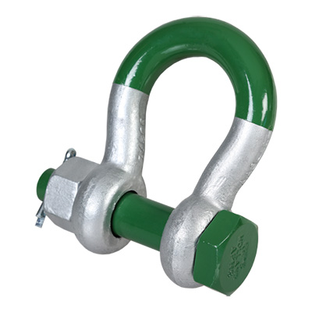Shackle: u-shaped, load-bearing connecting device designed to be strong, durdable, and capable of withstanding high stress and loads. Shackles are typically made of metal, and they come in a variety of shapes and sizes.

Drop down

Shackles are used in a wide variety of applications, including:

* Lifting and rigging: Shackles are used to lift and move heavy objects. They are typically used with other lifting equipment, such as cranes and hoists.
* Towing: Shackles are used to tow vehicles and other objects. They are typically used in conjunction with chains or tow straps.
* Securing: Shackles are used to secure objects in place. They are typically used to secure cargo, equipment, and livestock.

Choosing the Right Shackle

When choosing a shackle, it is essential to consider the following factors:

* Load capacity: The shackle must be able to support the weight of the load.
* Type of load: The shackle must be compatible with the type of load. For example, a chain shackle should not be used to tow a vehicle.
* Environment: The shackle must withstand the environment in which it will be used. For example, a shackle used in a marine environment must be made of stainless steel.
* Price: Shackles can range from a few dollars to hundreds of dollars. It is vital to choose a shackle that fits your budget.